**Mariam Abdallah**

**INFANT IMMUNIZATION**

The project aims at giving information to mothers and family with infant up to two years about baby care and the important of keeping the baby in good health and follow what is instructed be doctor. Like breast feeding the infant without giving it food for six months and also importance of breast feeding the babies for two years in physical and mental health.

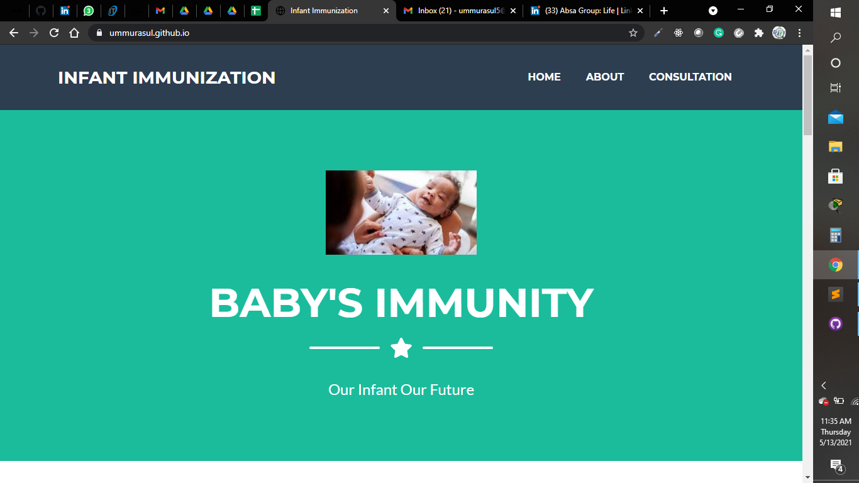

The site also gives the mothers insight when the baby to get which vaccine. Give the mothers schedule on when their kids should be taken for vaccine and also want to add module to locate nearest dispensary and notification.

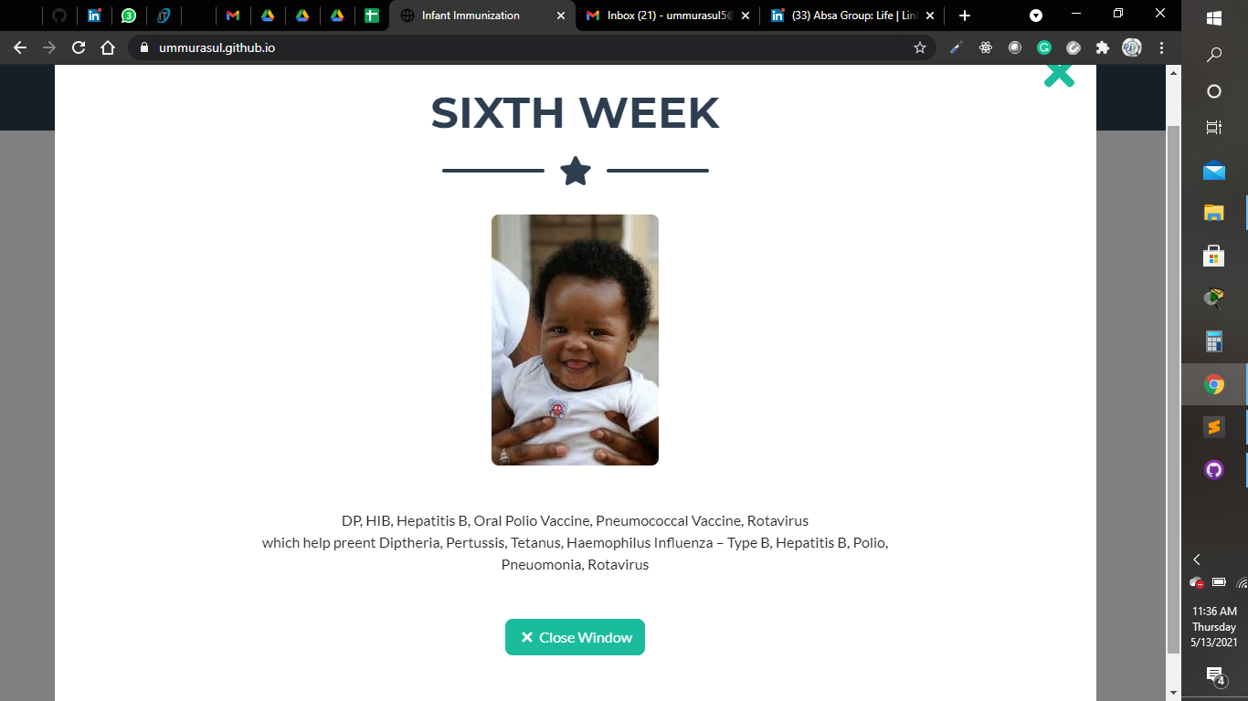

The mother can book an appointment to speak to specialist or can also contact using social media any time when need arise.

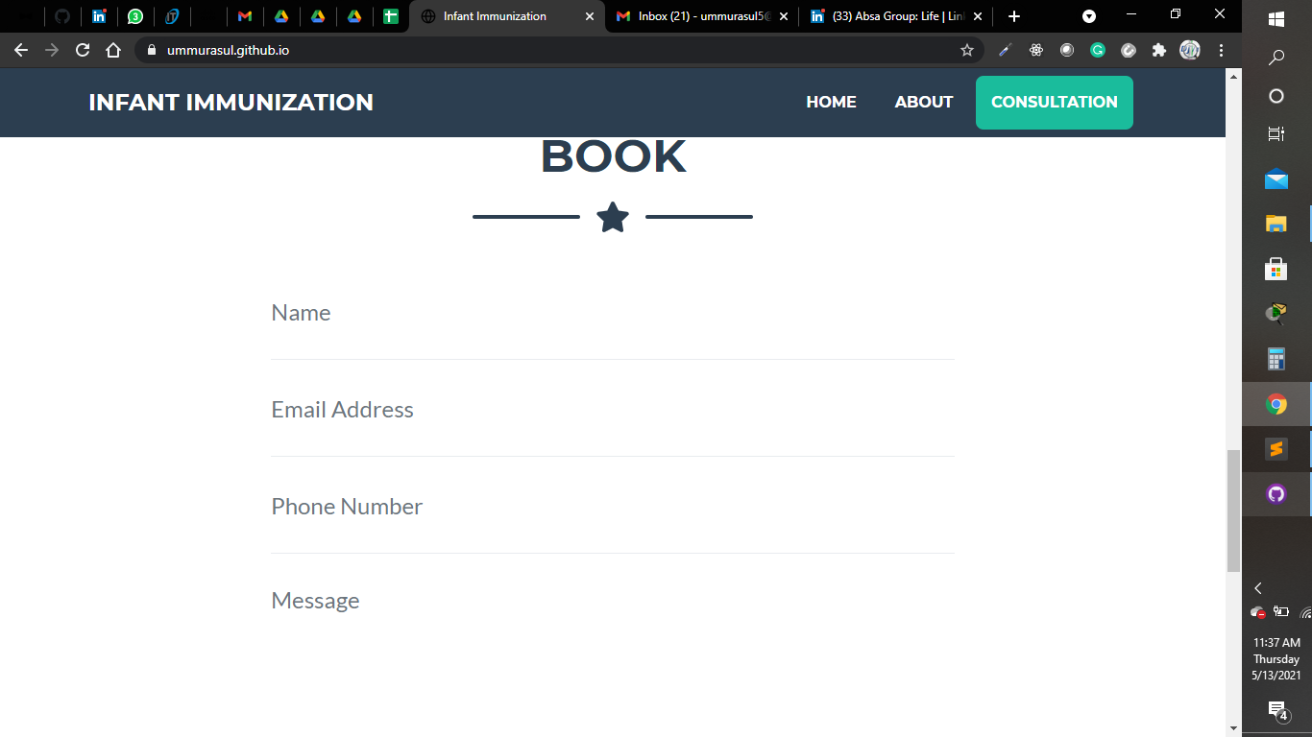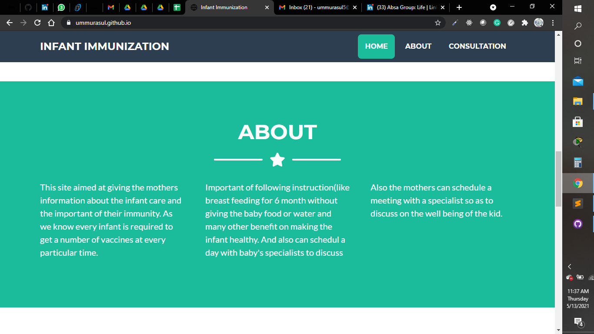

**Experience and Skills**

The program sharpened my skills on web development and made me realize the that I can be able to express my ideas using website.

I can now comfortable create a website and the facilitator from Pwani Teknogalz are so helpful willing to guide anytime we require their assistance.

Additional the program made me developed an interest to learn more on mobile application development and cybersecurity.